**Configuring DHCP and Web Server in Cisco Packet Tracer**

DHCP is an Internet control protocol used to assign an IP address to any appliance, or node, on an internet network so they can transmit data using IP. DHCP automatically handles these configurations rather than requiring network administrators to manually set IP addresses to all network devices. DHCP can be executed on small local networks, as well as large company networks. .

**Steps:**

**Step 1:** First, open the cisco packet tracer desktop and select the devices given below:

| **S.NO** | **Device** | **Model Name** | **Qty.** |
| --- | --- | --- | --- |
| **1.** | PC | PC | 1 |
| **2.** | switch | PT-switch | 1 |
| **3.** | server | Server-PT | 2 |

**IP Addressing Table**

| **S.NO** | **Device** | **IPv4 Address** | **Subnet Mask** | **Default Gateway** | **DNS** |
| --- | --- | --- | --- | --- | --- |
| **1.** | PC0 | 192.168.5.11 | 255.255.255.0 | 192.168.5.1 | nil |
| **2.** | server0 | 192.168.5.12 | 255.255.255.0 | 192.168.5.1 | nil |
| **3.** | DNS | 192.168.5.13 | 255.255.255.0 | 192.168.5.1 | 192.168.5.13 |

* Then, create a network topology as shown below the image.
* Use an Automatic connecting cable to connect the devices with others.

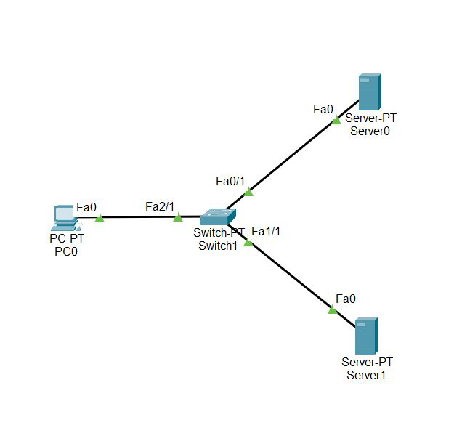

**Step 2:** Configure the PCs (hosts) Server0 and DNS with IPv4 address and Subnet Mask according to the IP addressing table given above.

* To assign an IP address, click on the device.
* Then, go to desktop and IP configuration and there you will find IPv4 configuration.
* Fill IPv4 address and subnet mask and other inputs.

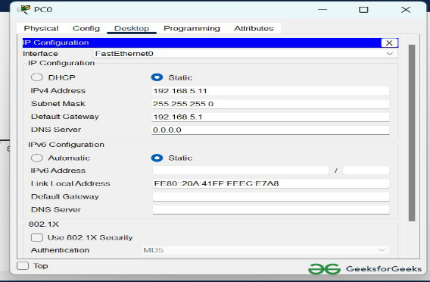

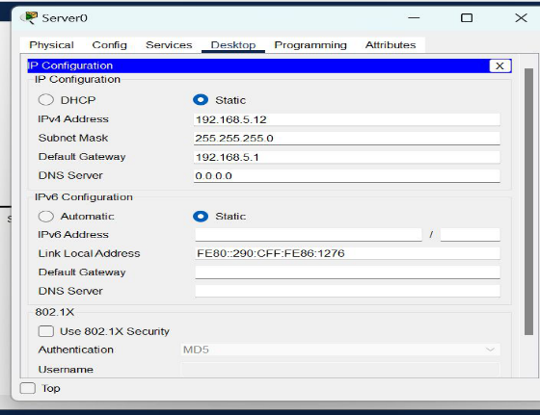

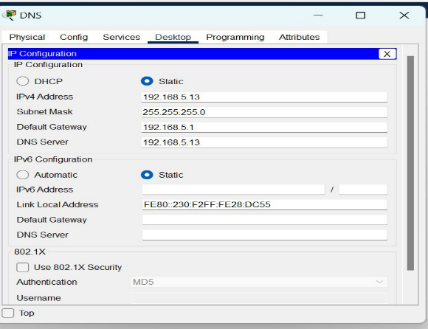

**Step 3:** Configure the HTTP sever0

* To configure the HTTP server.
* Go to services then click on HTTP
* Then delete all of the files except the index.html and edit it.

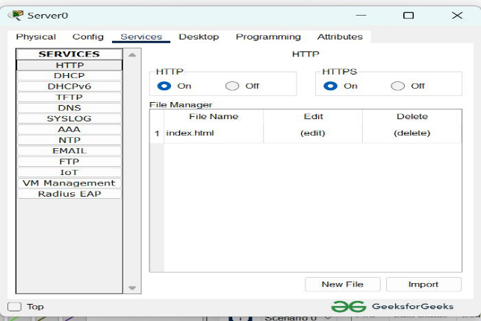

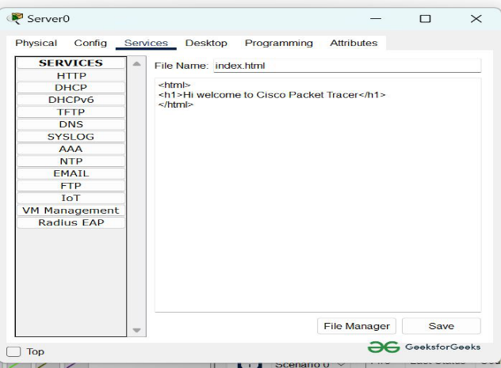

**Step 4:**Configure the DNS server

* To configure the DNS server.
* Go to services then click on DNS.
* Then turn on the DNS services.
* Name the server cisco.com and type address 192.168.5.12
* And add the record.

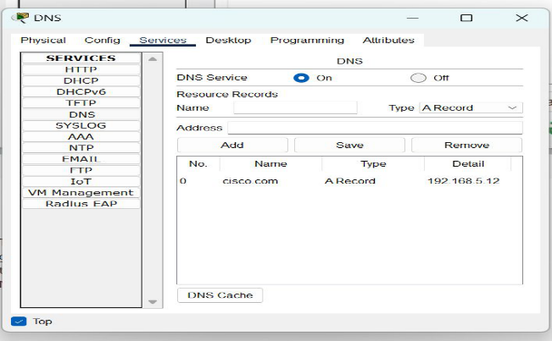

**Step 5:**Verify the server by using the web browser in the Host.

* Enter the IP address of server0 and click on GO.
* It will show the results.

